What is COP26: Politics, Policy and Net Zero
The United Nations Climate Change Conference of the Parties, or COP as it is better known, will be held this November in Glasgow. This year's COP will be the 26th in the series. The first was held in 1995 with Berlin being chosen as the host city. But of the 25 conferences to date, some have made a greater splash than others. For example, in 1997 COP3 saw the adoption of the Kyoto Protocol - a binding agreement which set a commitment to limit and reduce global greenhouse emissions. Then in 2015, COP21 produced the Paris Climate Accords which are notable for the goal of restricting the rise of global temperatures to a preferable limit of 1.5°C, this subsequently generated momentum for the Net Zero Carbon movement.
Building Services Engineers + Environmental Design Consultants + Fire Engineers + Lighting Designers
atelierten.com
But beyond the grand titles and inaccessible legal language, these conferences have a significant impact not only on the buildings and assets we all work with, but on our lives, our future and society in general.
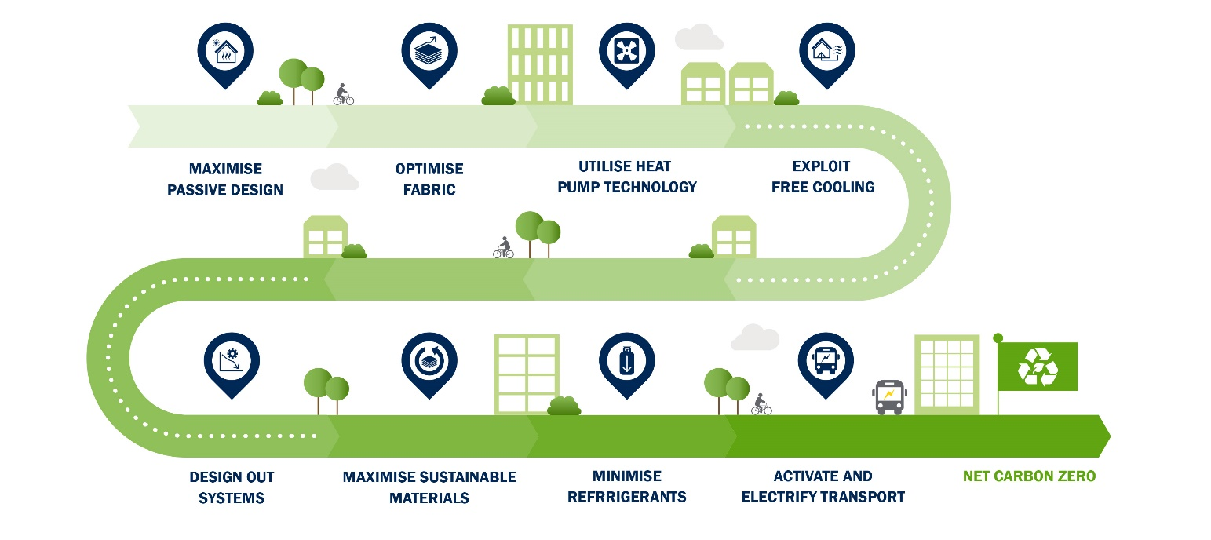
The genesis of COP goes back all the way to 1972 to the first Earth Summit. The Earth Summits are generally intended to occur every ten years. And by 1992 - at the third Earth Summit in Rio de Janeiro - great momentum had developed behind the sustainability movement. This momentum had grown during the 1980's, driven by public sentiment as a consequence of the widespread reporting on the hole in the ozone layer. This story was clearly newsworthy and it helped bring attention to the damage human beings were having on the natural environment. The 1980's was also the decade in which the modern and widely accepted definition of Sustainable Development was produced by the UN formed Brundtland Commission, this definition being:
'Sustainable development is development that meets the needs of the present without compromising the ability of future generations to meet their own needs.'
Within this definition of Sustainable Development there are three key themes: Economic Growth, Environmental Protection and Social Equality. Human activity, the things we do, the decisions we make, are deeply nestled between and within these themes. And the COP event this November is likely to reshape - to some degree or another - how we live and work.
Responding to this vast expansive reach of sustainability, REVO have formed an Environmental Working Group, led by David Cameron of Atelier Ten and a Social Impact Working Group, led by Kate Neale of Cadogan Estates. Both groups will be following November's events in Glasgow very closely.
COP26 is particularly important because it is at this event participating countries are expected to present updated and finalised individual national action plans to cut greenhouse gas emissions.
The Paris Climate Accords require such action plans on emission reductions to be developed by all participating nations - including the United Kingdom. These action plans are projected to be reviewed every five years, with COP31 likely to be the next high-profile conference in the series.
But with change needed now, many see COP26 as being a last chance to meaningfully change our relationship with our invisible neighbour, the natural environment. Approximately 197 countries will take part in the talks, but it is important a unified agreement is reached. The climate and natural environment realise no borders or boundaries. One nations drought will be another's monsoon.
COP26 is scheduled to last 12 days, within which negotiations will take place to reduce emissions, strengthen adaption to resilience and climate change impacts and to scale up finance and support. But previous COP events have been known to overrun due to stalemates and a lack of collective progress. It is the last week of the event the politicians take centre stage, and this tends to be where matters become fractious. Given the serious nature of the climate impacts reported in the recent IPCC AR6: Climate Change 2021, the future context of failure at COP26 is scientifically set and very much in our midst.
Of course, the event in its official capacity will not only attract ministers and politicians who have an official role, but there will be non-government organisations such as Greenpeace, intergovernmental organisations such as OPEC, official observers and UN agencies such as the World Health Organisation within the official sphere of the conference.
Then there is the side-show of exhibitions and events. This will take place within the rented halls and conference spaces, wherein stakeholders and businesses will look to promote innovations and ideas to those willing to listen.
And outside there will be the protesters: people from all walks of life looking to ensure their voices are heard on the matters which are important to them - and likely all of us. This particular segment of the event has grown in size and volume since the first COP back in Berlin. This reflects the global importance of the outcomes and the growing public concern over the lack of sufficient progress.
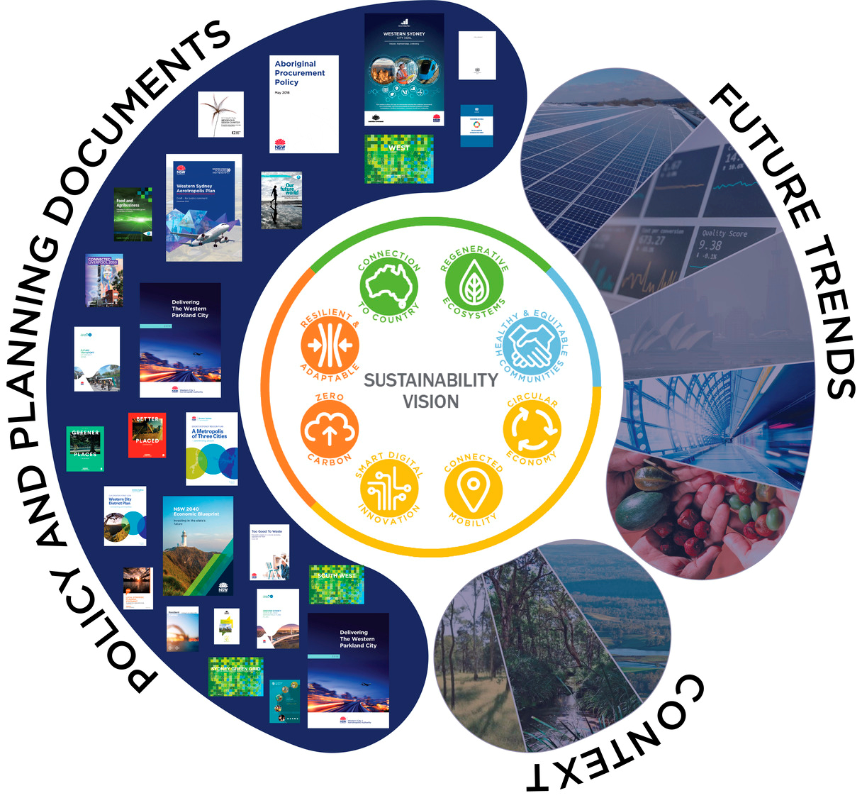
The United Kingdom will be negotiating at COP26 as an individual nation for the first time - the nations forming the European Union negotiate as a singular entity. The presidency of the event will be shared between Italy and the United Kingdom. Like many other countries, Italy has witnessed great momentum behind environmental and social movements through groups such as Youth4Climate. And at a series of pre-COP events held in Milan there will be a conference of young people from across the globe who will then submit their proposals and recommendations to governments for discussion in Glasgow.
If the politicians are successful at COP26, we will all likely have a role to play, even if that is simply sheering the edges of consumption from our lives. We will all need to live within a far more modest relationship with the natural environment.
If the politicians are not successful, we will all likely have to solve matters within bubbles of a disjointed global response without cohesive hope.
COP26 is a political negotiation with our invisible neighbour and politics trades in the welfare of humankind. COP26 impacts our lives in ways we may not appreciate. The global hope in November should be a unilateral response which shapes a more sustainable world.

